DB Health Check – Beginners’ Guide

DB Health Check

© Footsteps infotech inc

Email: subodh@footstepsinfotech.com
Web: www.footstepsinfotech.com



Version History

Date | Version | Author | Description
August 01st, 2015 | V0.1 | Subodh Shah | Initial Draft
August 03rd, 2015 | V0.2 | Subodh Shah | Modified All Sections after review
August 04th, 2015 | V1.0 | Subodh Shah | Version Freeze

The Purpose
Provide a utility for database Maintenance and Optimization tool for managing and maintaining health of large databases. As database grown over time, the performance starts degrading with issues like high page fragmentation, slow query execution, large data reads etc. Don’t Worry! DB Health Check comes to the rescue. With a one click installation, leave all the database maintenance issues to us, and we will take all the pains to get it sorted.

The Installation
The Following are the steps attached with the screenshots.
- Download the latest DB Health Check installable from the link provided or check http://www.footstepsinfotech.com.
- Once the download is complete, right click the setup and click “Run as Administrator” as the tool requires administrator access to make changes to the scheduler service. Note: If you are already logged into the Windows with an Administrator Account, you can directly double click on the Setup.exe
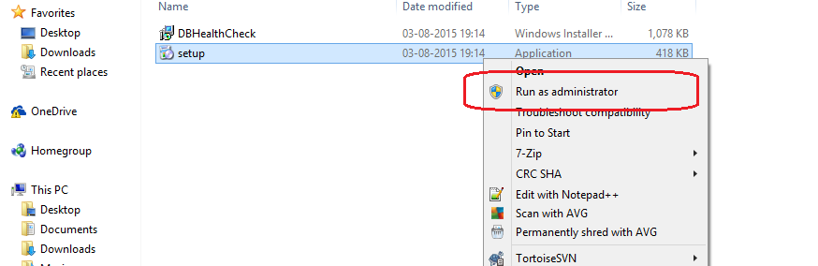
- Click Next
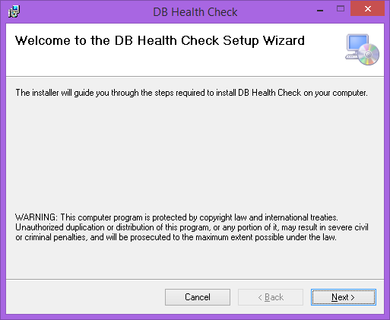
- Accept the License Agreement and Click on Next Button
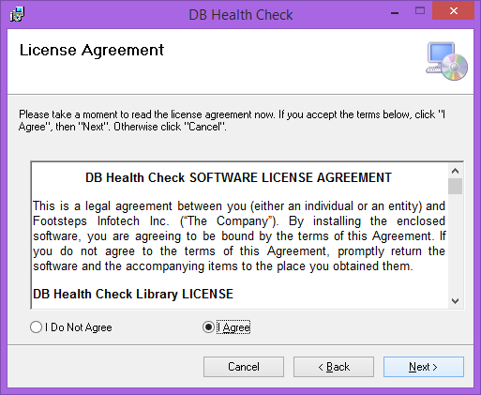
- Now you will be presented with the following screen.
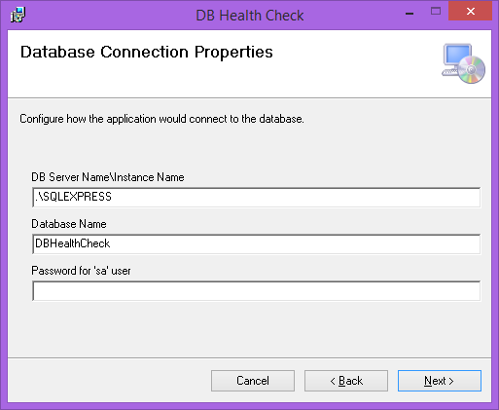
This page takes the parameters for setting up connection string or database connection parameters. You can change the parameters later on from the application, if required.
  - Please provide the SQL Server IP Address and instance name in the first text.
  - Enter the Database Name in the second Text Box. The database would be created if it does not already exist.
  - Please enter the password for “sa” user. The “sa” user is the created by default at the time of SQL server installation. The “sa” user has the public and more importantly sysadmin role which is required for create a new database. Once the database is created you can change the user to be normal user later after the application is installed.3
  - Click Next
- Select the Directory in which you wish the application to be installed, and click next.
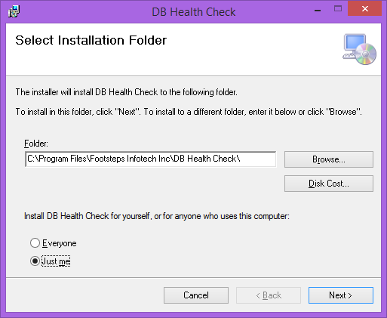
- Click Next to Begin Installation.
- Wait for the installation to complete.
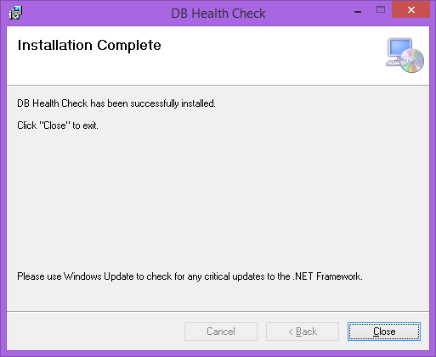
- Click Close
- After Installation, go to the installation folder and you should see UserConfig.exe File. Double click on the file to start the application.
Configuration Settings
You can navigate to the configuration tab of the application to modify the various configuration parameters. Click on the settings to modify the parameters.
- Database Connection String. Click on Configuration -> Connect Parameters
  - Server IP – the IP address of the server to connect to. (e.g. 182.18.185.65)
  - Instance Name – The default for SQL Server Express Edition is SQLEXPRESS
  - Database Name – The name of the database if 1 already exists or create the new database with the name specified.
  - User Id – The login name which should be for connecting to the database. (PS: the login should be in sysadmin role for the solution to get correctly installed and work correctly.)
  - Password – The password for the login name.
  - Click Ok to Save the changes
  - Click Test Connection to check if the connection has been established.
  - Restart the application for the changes to take effect.
- Mail Alerts – Click on Configuration -> Mail Alerts
  - Enable Mail Alerts. Click on the link to enable mail alerts.
  - Mail alerts are used to send out emails whenever an operation executes on its schedule. The mail alerts sends out the log for the execution attached to the email.
  - Once the mail alerts are enabled you would be able to modify the mail alert parameters.

- Mail Parameters Go to Configuration -> Mail alerts -> Mail Setup Parameters.
  - Display Name – Name to be displayed to the receiver as to who has sent the message
  - Email from – Email address from which the emails are to be sent.
  - Mail server – Server address to be used for sending the emails.
  - SMTP Port – Server Port number. Leave the value to 0 for default value.
  - User name – Server username for sending the emails, usually same as the email address
  - Password – Password for the account for sending the email alerts
  - Mail to – List of email address to which the email alerts should be sent.
  - Click on Save Settings in order to save the changes.
  - Once the settings are saved you would be able to Test the settings. Click on Test
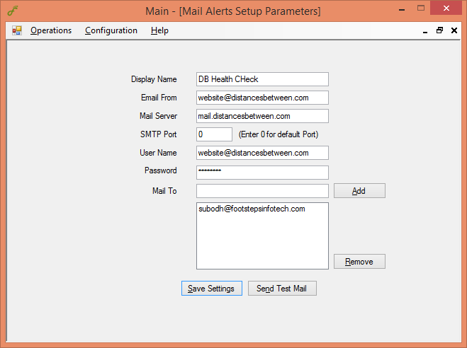
  - Click on Sent Test Mail to Test the settings.

- Automatic Scheduling – Configuration -> Automatic Scheduling -> Scheduling (Click to Enable)
  - Click on Automatic Scheduling to auto Schedule Database Maintenance
  - Once the auto schedule is enabled, you can then schedule the Statistics maintenance, database backup and database integrity checks on hourly, daily, weekly, monthly, fortnightly, yearly, etc.

- Database Compression – Configuration -> Database Compression -> Compress Backup (Click to Enable)
  - Click on Compress Database Compressing the backups after a backup run, helps in savings disk space and is useful while transferring the database from 1 backup to other, also helps in quick recovery of the backup.

- Index and Statistics Maintenance – Operations -> Update Statistics
  - Enter the various parameters for Index Maintenance. The details for each parameters are in Appendix I
  - Click on Optimize Indexes button to immediately run the operation.
  - Index Maintenance helps in improving query performance, and reducing page fragmentation.
  - If Automatic Scheduling is enabled you should be able to see the Schedule Maintenance button which should help in schedule the operation as per your needs.
  - Since the Command can take considerable time to execute, we cannot use the default time out; provide a value based on the database size.
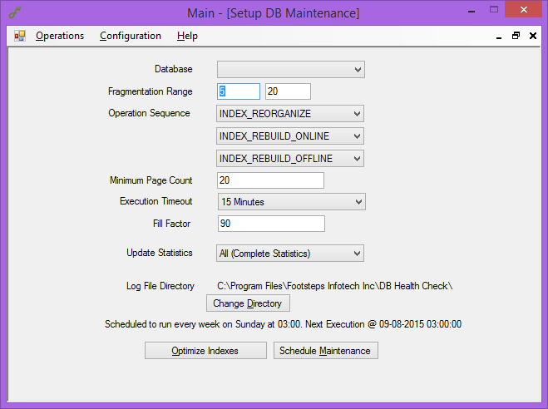
  - Scheduling – Please refer scheduling section

- Database Integrity Check – Operations -> Database Integrity Check
  - Enter the various parameters for Database Integrity Check. The details for each parameters are in Appendix II
  - Database Integrity check helps in identifying problems with the database objects, like indexes, views etc if those were created earlier and underlying tables/objects were modified at a later date.
  - Click on Run Check Now button to immediately run the operation.
  - If Automatic Scheduling is enabled you should be able to see the Schedule Check button which should help in schedule the operation as per your needs.
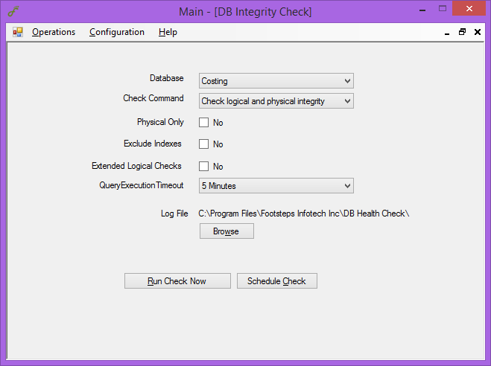
  - Scheduling – Please refer scheduling section

- Database Backup – Operations -> Backup Database -> Backup Type
  - Select the backup type based on your needs.
  - Enter the various parameters for Database Backup. The details for each parameters are in Appendix III
  - Click on Backup Now button to immediately run the operation.
  - If Automatic Scheduling is enabled you should be able to see the Schedule Backup button which should help in schedule the operation as per your needs.
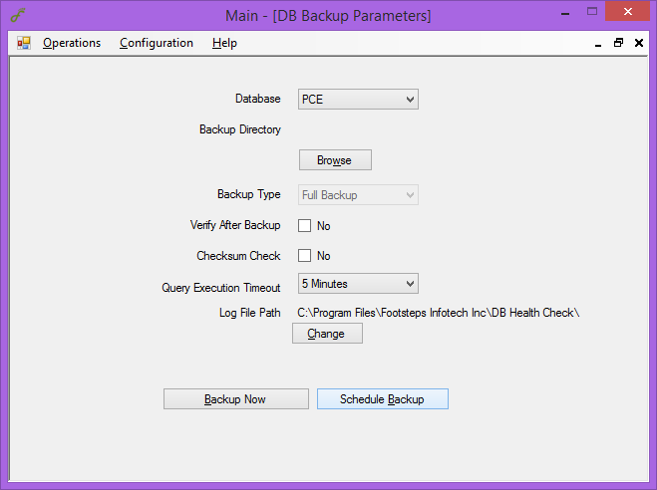
  - Scheduling – Please refer scheduling section

- Scheduling – Using scheduling you can schedule all operation which will run automatically based on your preference.
  - First Scheduling needs to be enabled throughout the application. Please refer Sec. 4. For more details
  - Click on Scheduling you would be presented with a screen similar to below
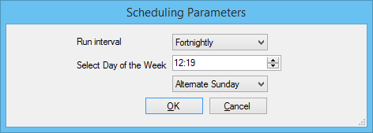
  - You can select various run interval frequency for a range of values like Hourly, Daily, Weekly, Fortnightly, Monthly, Yearly, etc.
  - Based on the selected you would be asked for the additional information which will be helpful in performing the task.
  - Once the settings are saved, the Task would be scheduled using the Windows Task Scheduler service and would be invoked at the specified time.
  - Mail would be sent based on the mail alert configuration settings.

Appendix I
- Fragmentation Range - Based on the fragmentation value, we define the operation into 3 values
  - Fragmentation Low – Objects should fragmentation is between 0 and specified low value
  - Fragmentation Medium – Objects with fragmentation between the range specified
  - Fragmentation High – Object with fragmentation above the High specified value
- Operation Sequence – Details of the Operation which are performed
Value | Description
INDEX_REBUILD_ONLINE | Rebuild index online.
INDEX_REBUILD_OFFLINE | Rebuild index offline.
INDEX_REORGANIZE | Reorganize index.
INDEX_REBUILD_ONLINE,INDEX_REBUILD_OFFLINE | Rebuild index online. Rebuild index offline if online rebuilding is not supported on an index.
INDEX_REBUILD_ONLINE,INDEX_REORGANIZE | Rebuild index online. Reorganize index if online rebuilding is not supported on an index.
INDEX_REORGANIZE,INDEX_REBUILD_ONLINE,INDEX_REBUILD_OFFLINE | Reorganize index. Rebuild index online if reorganizing is not supported on an index. Rebuild index offline if reorganizing and online rebuilding are not supported on an index.
NULL | Do not perform index maintenance. This is the default for a low-fragmented index.
An online index rebuild or an index reorganization is not always possible. Because of this, you can specify multiple index-maintenance operations for each fragmentation group. These operations are prioritized from left to right: If the first operation is supported for the index, then that operation is used; if the first operation is not supported, then the second operation is used (if supported), and so on. If none of the specified operations are supported for an index, then that index is not maintained.
Index Optimize uses the SQL Server ALTER INDEX command: REBUILD WITH (ONLINE = ON) to rebuild indexes online, REBUILD WITH (ONLINE = OFF) to rebuild indexes offline, and REORGANIZE to reorganize indexes.

- Page Count Level
Set a size, in pages; indexes with fewer pages are skipped for index maintenance. The default is 1000 pages. Index Optimize checks page_count in sys.dm_db_index_physical_stats to determine the size of the index.
- Fill Factor
Indicate, as a percentage, how full the pages should be made when rebuilding indexes. If a percentage is not specified, the fill factor in sys.indexes is used.
The Fill Factor option in Index Optimize uses the FILLFACTOR option in the SQL Server ALTER INDEX command.
- Update Statistics
Value | Description
ALL | Update index and column statistics.
INDEX | Update index statistics.
COLUMNS | Update column statistics.
NULL | Do not perform statistics maintenance. This is the default.

Index Optimize uses the SQL Server UPDATE STATISTICS command to update statistics.

Appendix II
- Check Commands –
Value | Description
CHECKDB | Check the database. This is the default.
CHECKFILEGROUP | Check the file groups.
CHECKTABLE | Check the tables and the indexed views.
CHECKALLOC | Check the disk space allocation structures.
CHECKCATALOG | Check the catalog consistency.
CHECKALLOC,CHECKCATALOG | Check the disk space allocation structures and the catalog consistency.
CHECKFILEGROUP,CHECKCATALOG | Check the file groups and the catalog consistency.
CHECKALLOC,CHECKTABLE,CHECKCATALOG | Check the disk space allocation structures, the tables and the indexed views, and the catalog consistency.

Database Integrity Check uses these SQL Server DBCC commands: DBCC CHECKDB to check the database, DBCC CHECKFILEGROUP to check the file groups, DBCC CHECKTABLE to check the tables and the indexed views, DBCC CHECKALLOC to check the disk space allocation structures, and DBCC CHECKCATALOG to check the catalog consistency.

- Physical Only - Limit the checks to the physical structures of the database.
Value | Description
Yes | Limit the checks to the physical structures of the database.
No | Do not limit the checks to the physical structures of the database. This is the default.

The Physical Only option in Database Integrity Check uses the PHYSICAL_ONLY option in the SQL Server DBCC CHECKDB, DBCC CHECKFILEGROUP, and DBCC CHECKTABLE commands.

- No Index - Do not check non-clustered indexes.
Value | Description
Yes | Do not check non-clustered indexes.
No | Check non-clustered indexes. This is the default.

The No Index option in Database Integrity Check uses the NOINDEX option in the SQL Server DBCC CHECKDB, DBCC CHECKFILEGROUP, DBCC CHECKTABLE, and DBCC CHECKALLOC commands.

- Extended Logical Checks - Perform extended logical checks.
Value | Description
Yes | Perform extended logical checks.
No | Do not perform extended logical checks. This is the default.
The Extended Logical Checks option in Database Integrity Check uses the EXTENDED_LOGICAL_CHECKS option in the SQL Server DBCC CHECKDB command. You cannot combine the options Physical Only and Extended Logical Checks.

Appendix III
- Directory - Specify backup root directories, which can be local directories or network shares. If you specify multiple directories, then the backup files are striped evenly across the directories. Specify multiple directories by using the comma (,). If no directory is specified, then the SQL Server default backup directory is used.
Value | Description
NULL | Back up to the SQL Server default backup directory. This is the default.
C:\Backup | Back up to the directory C:\Backup.
C:\Backup, D:\Backup | Back up to the directories C:\Backup and D:\Backup.
\\Server1\Backup | Back up to the network share \\Server1\Backup.
\\Server1\Backup, \\Server2\Backup | Back up to the network shares \\Server1\Backup and \\Server2\Backup.
Database Backup creates a directory structure with server name, instance name, database name, and backup type under the backup root directory. If the database is a part of an availability group, then cluster name and availability group name are used instead of server name and instance name.

- Backup Type – Specify the type of backup: full, differential, or transaction log.
Value | Description
FULL | Full backup
DIFF | Differential backup
LOG | Transaction log backup

Database Backup uses the SQL Server BACKUP command: BACKUP DATABASE for the full backup, BACKUP DATABASE WITH DIFFERENTIAL for the differential backup, and BACKUP LOG for the transaction log backup.

- Verify - Verify the backup.
Value | Description
Yes | Verify the backup.
No | Do not verify the backup. This is the default.

The Verify option in Database Backup uses the SQL Server RESTORE VERIFYONLY command.

- Check Sum – Enable backup checksums.
Value | Description
Yes | Enable backup checksums.
No | Do not enable backup checksums. This is the default.

The Check Sum option in Database Backup uses the CHECKSUM option in the SQL Server BACKUP command.

